**Part #C1 Reader PCB vB6_0-EQ**

EQ1: We found single traces in the inner layers and outer copper layers. Please confirm if we need to proceed as per the Gerber data.

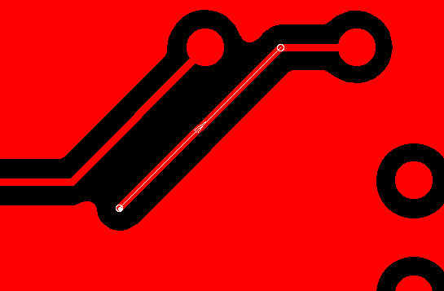**-> Copper Inner 2**

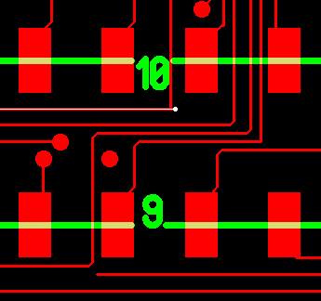 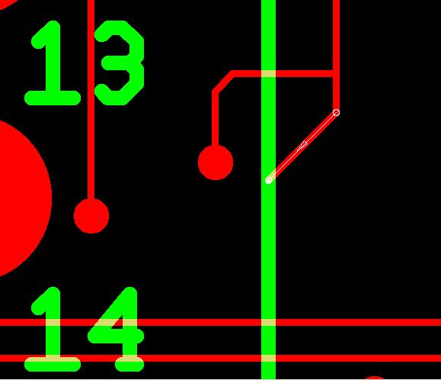**-> top layer**

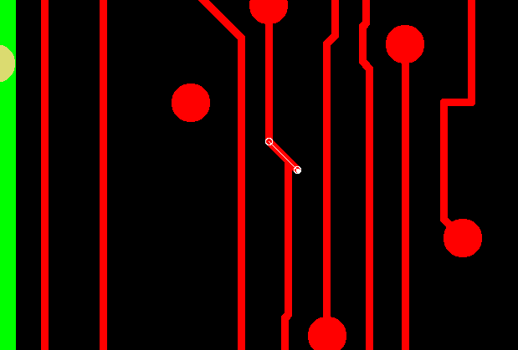**-> bottom layer**

EQ2: There is no copper pads present for the 125mil drills but it is mentioned as PTH drill so please confirm if we can proceed as NPTH drills?

